Asha White Paper  V1.0 | AI First - Community Driven, Meme Token about Asha the Elephant set on taking our place as Queen of the Solana Jungle.  Links  Website – https://www.ashacoin.com/  Telegram - https://t.me/ashacoin  Discord - https://www.ashacoin.com  Contract Address (Solana)  8GLJPLJ8L5v3d7Umt8HfTdhfkJuMm68U5t2sQHVkZEQo

Introduction
Asha Coin represents a revolutionary step in leveraging cryptocurrency for social change, drawing inspiration from the poignant story of Asha, an elephant who has lived a life of solitude within the confines of a zoo. This digital token transcends the boundaries of traditional cryptocurrencies by embodying the spirit of resilience, solidarity, and the collective yearning for freedom that Asha represents. It's more than a financial instrument—it's a beacon of hope for captive elephants worldwide and a testament to the power of community-driven change.

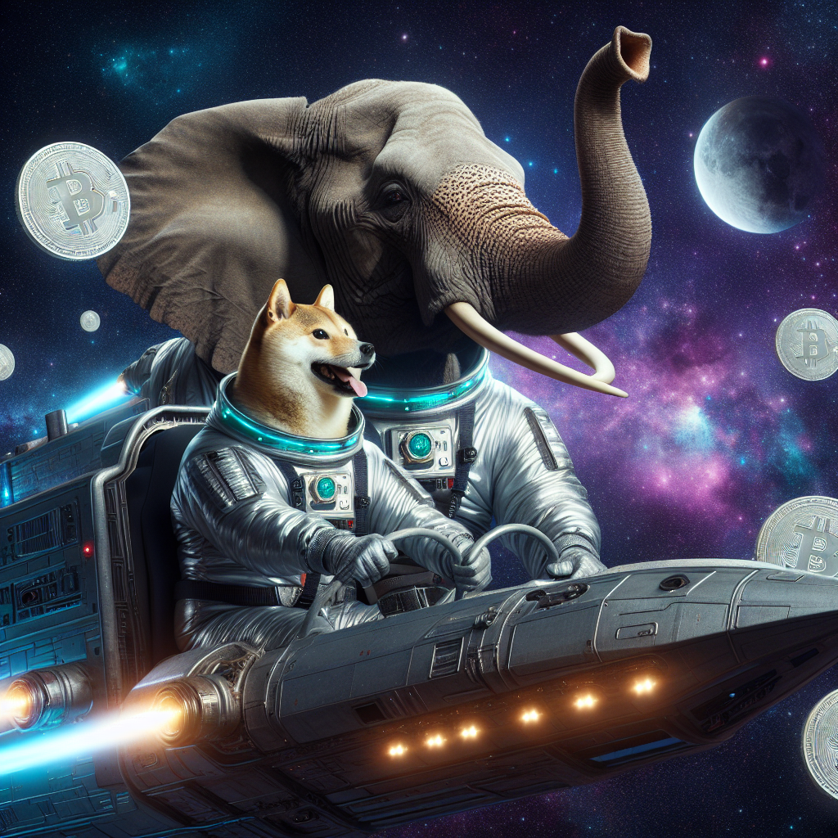

Background

Captive elephants like Asha endure lives marked by isolation and restriction, a stark contrast to the wide-ranging, social, and dynamic existence they would lead in the wild. Asha Coin seeks to illuminate their plight and foster a global movement towards their liberation and welfare. By intertwining the cause of these majestic beings with the innovation of cryptocurrency, Asha Coin aims to build a community united in compassion and action.

Mission and Values

Asha Coin is driven by core values that are integral to its identity and strategy:
- Solidarity: Standing together with Asha and all captive elephants, we aim to create a united front for change.
- Compassion: Our efforts are rooted in a deep empathy for the sentient beings under duress, motivating us to act.
- Innovation: By leveraging AI and blockchain technology, we push the boundaries of how cryptocurrency can serve a greater purpose.
- Community Engagement: Building a strong, active community is central to our approach, believing in the collective power to make a significant impact.
Our mission is to harness the potential of AI and blockchain to generate awareness, foster community engagement, and ultimately contribute to the liberation and betterment of humans and animals worldwide.

Community Engagement and Marketing Strategies

Asha Coin's approach to community engagement is characterized by creativity, interactivity, and the strategic use of AI:

- Social Media + AI Integration: Building a marketing suite of utilities that will further the message of Asha.
- AI Content Generation: Utilizing AI to create compelling, engaging content that can be shared across social platforms, enhancing visibility and community interaction.
- Influencer Partnerships: Collaborating with influencers to amplify our message and reach a wider audience.

Roadmap

Our roadmap outlines key milestones in the development, community building, and expansion of Asha Coin:
1. Launch Phase: Introduction of Asha Coin, establishment of the community, and initial marketing campaigns.
2. Technology Development: Enhancements to the AI chatbot, integration with social media platforms, and exploration of new blockchain functionalities.
3. Expansion Phase: Broadening the scope of Asha Coin's utility, partnerships with wildlife conservation efforts, and increased engagement strategies.
4. Innovation and Growth: Continual assessment of emerging technologies and opportunities for Asha Coin to contribute to both the crypto and conservation sectors.

Future Aspirations

Looking ahead, Asha Coin envisions expanding its utility and influence within the cryptocurrency space. Beyond raising awareness for Asha and captive elephants, we aim to explore new avenues where AI can revolutionize engagement, utility, and philanthropy in the crypto world, always guided by our foundational values.
Asha Coin stands at the intersection of technological innovation and a deep-rooted desire for positive social change. It is more than a cryptocurrency; it is a movement fueled by compassion, driven by advanced technology, and supported by a community committed to making a real difference. By investing in Asha Coin, stakeholders are not just participating in a financial venture but are becoming part of a global effort to address the ethical treatment of elephants and other wildlife. This initiative represents a new frontier where the power of blockchain and AI is harnessed for the greater good, proving that technology can be a force for change and a tool for advocacy.
As we look to the future, Asha Coin is poised for growth not only in the crypto market but also as a leading example of how cryptocurrency projects can transcend traditional boundaries to impact the world positively. We invite you to join us in this journey, to be part of a community that values innovation, compassion, and action. Together, we can create a legacy that combines the best of technology with the best of humanity, for Asha, for elephants everywhere, and for the world.

Join the Movement

- Engage: Join our community on Telegram and follow us on Twitter to stay updated with the latest news and engagements.
- Contribute: Participate in our creative prompts, share your ideas, and help spread the word about Asha Coin's mission.
- Invest: By acquiring Asha Coin, you're supporting a project with a purpose, contributing to the welfare of elephants, and being at the forefront of crypto innovation.
For more information, visit our website at ashacoin.com and follow our journey towards making a tangible difference in the world with Asha Coin.

